Predicting the Rice leaf diseases using CNN

In this paper author is using VGG16 transfer learning neural network to train rice diseases dataset and after training we can use this model to predict disease from new images. To train VGG16 model author has used Rice Leaf dataset from KAGGLE and this dataset is small so training with small dataset may not give good result so author using transfer learning CNN algorithm where already inbuilt CNN model can be transfer and train with our small dataset to get better prediction result.

In propose paper author building Normal CNN model without transfer learning and with VGG16 transfer learning and in both model VGG16 transfer learning is giving better prediction accuracy.

Below is the dataset screen shots used to train VGG16 model.

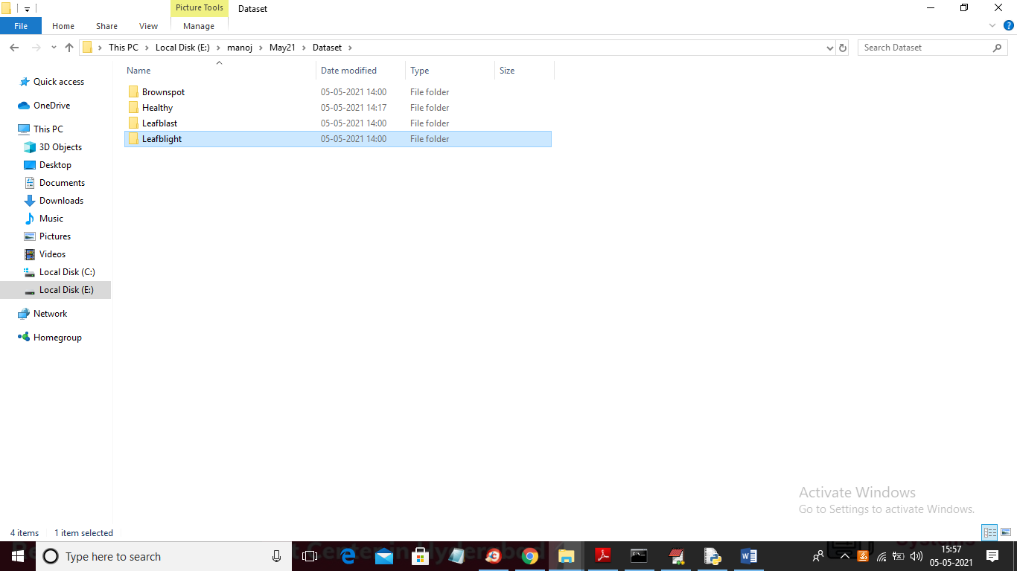

To train VGG 16 we are using rice dataset which contains 4 different types of images or disease and you can go inside any folder to view its images

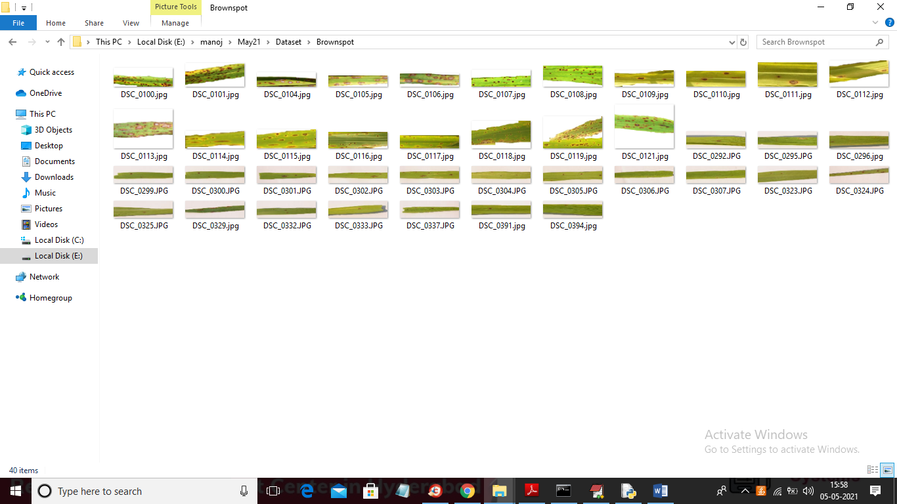

In above screen you can see images from ‘Brownspot’ disease. After training model we can use below test images to predict diseases and test images are available inside ‘testImages’ folder

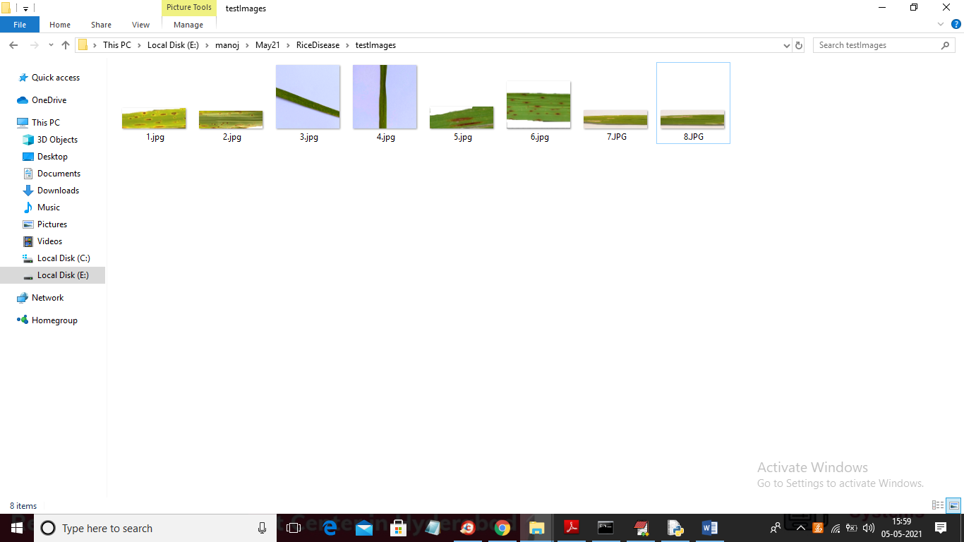

Above test images can be uploaded to application to predict their disease status.

To implement this project we have designed following modules

1. Login: This is an online application and user need to login by using username as ‘admin’ and password as ‘admin’
2. Train CNN Algorithms: After login user can use this model to train normal CNN and VGG16 CNN with above rice disease dataset and after training model we will calculate both models accuracy on test data.
3. Upload Rice Image: using this module we will allow user to upload rice leaf images and the application will predict condition of leaf as healthy or effected with disease.

SCREEN SHOTS

To run project install python 3.7 and tensorflow package 1.14.0 and then install Django==2.1.7

After installation run below command from ‘RiceDisease’ folder

Python manage.py runserver

Then open browser and enter URL as <http://127.0.0.1:8000/index.html> and press enter key to get below screen



In above screen click on ‘Login’ link to get below login screen



In above screen enter username as ‘admin’ and password as ‘admin’ and then click on ‘Login’ button to get below screen



In above screen click on ‘Train CNN Algorithms’ link to train both VGG16 and normal CNN without transfer learning on rice dataset and then calculate prediction accuracy

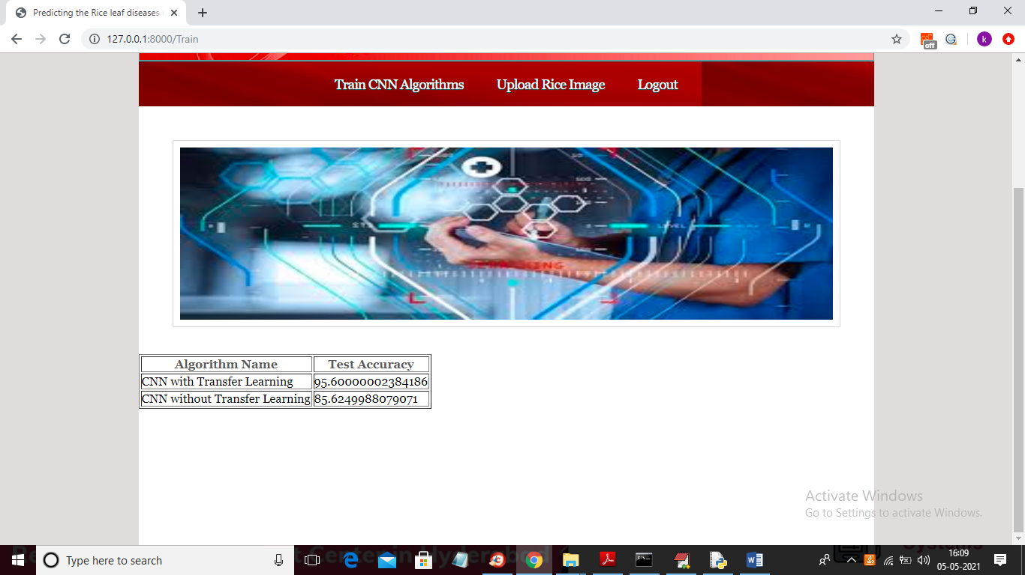

In above screen CNN with transfer learning VGG16 got 95% accuracy and without transfer learning got 85% accuracy so VGG16 is giving better result. In below console you can see layer details of VGG 16 and Normal CNN

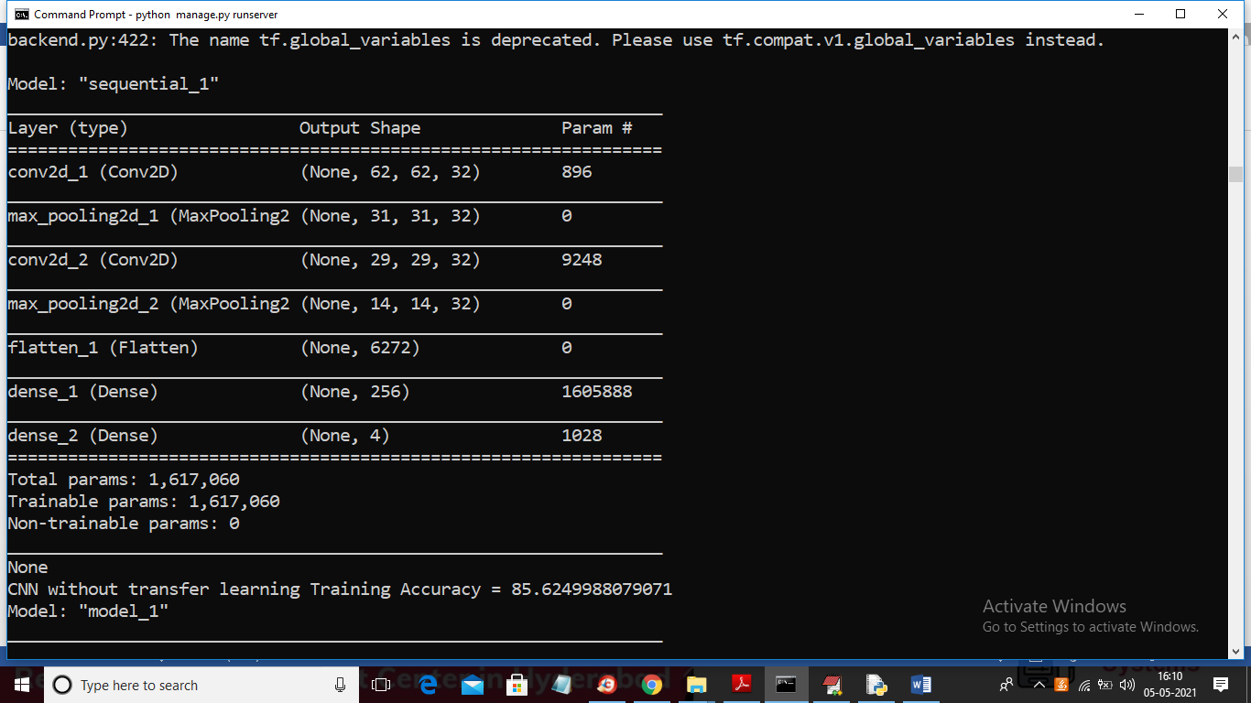

In above screen normal CNN created 4 layers and got 85% accuracy and in below screen you can see VGG16 layers

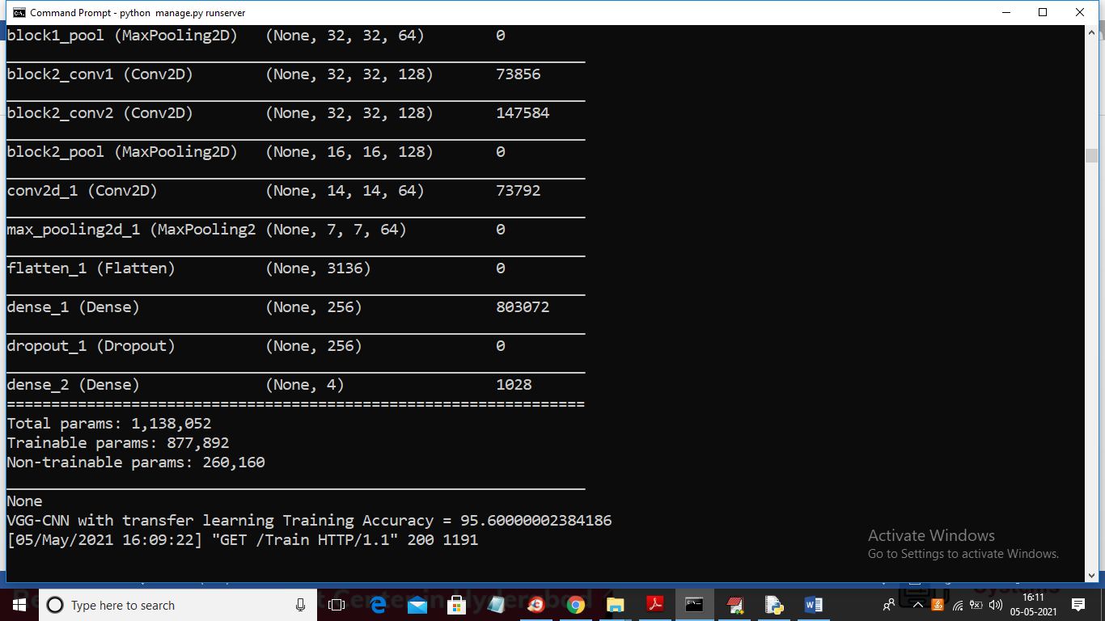

In above screen VGG16 contains so many layers and its accuracy is 95% and now in below screen click on ‘Upload Rice Image’ link



Now in above screen click on ‘Choose File’ button to upload leaf test image from ‘testImages’ folder

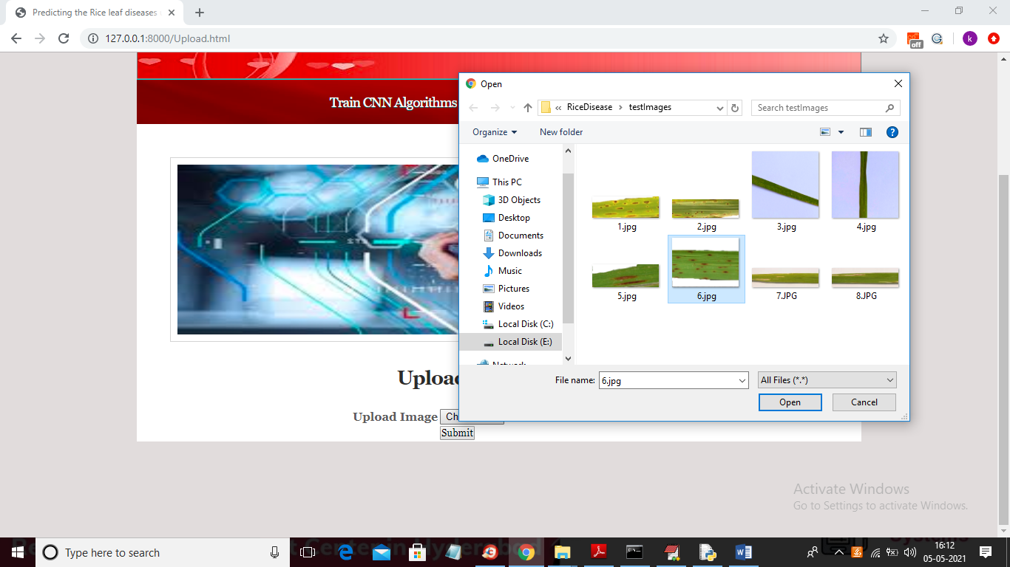

In above screen selecting and uploading ‘6.jpg’ file and then click on ‘Open’ button then click on ‘Submit’ button to get below result

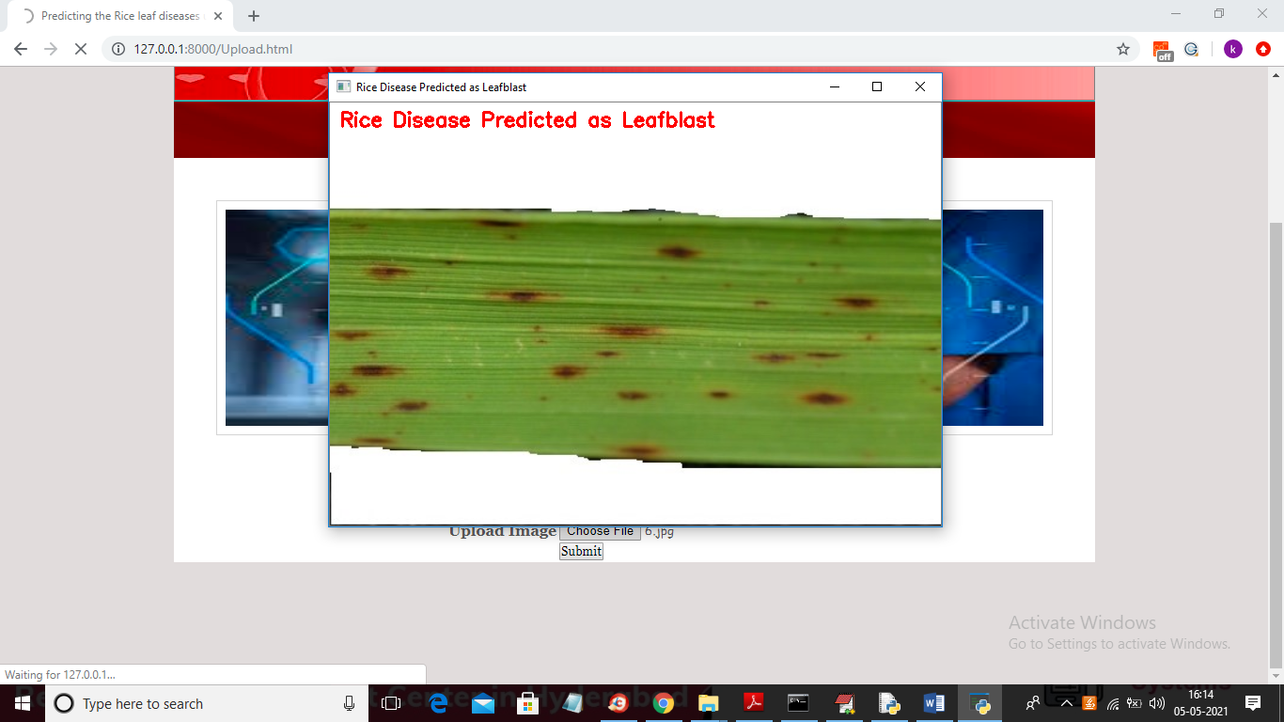

In above screen in uploaded image disease predicted as ‘Leaf Blast’ and now test other image

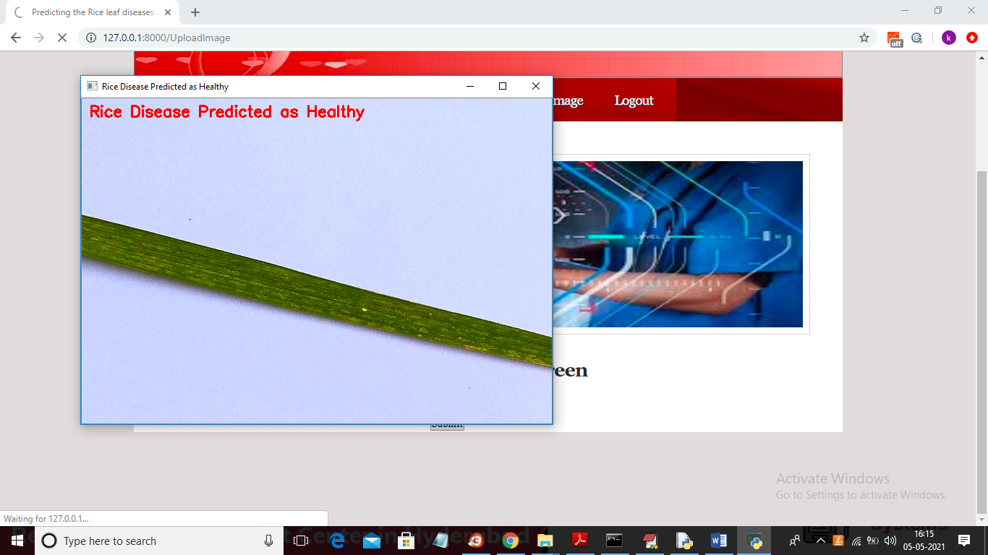

In above screen leaf predicted as healthy and similarly you can upload other images and test them